Welcome Club –Perseverance 1
Staff contact: Megan 916-937-1365
Materials
General | Masks, Clip board, snack, water, name tag, hand sanitizer, pens, pencils, markers, check-in sheet
Maze building | shallow cardboard box, large plastic straws, popsicle sticks, scissors, pencils, marbles, low temp hot glue gun, glue sticks
Fitness challenge | balls, jump rope, hula hoops, chalk
Homework | Homework boxes, markers, pencils

Objective
Students will be able to understand how to make a personal goal.

Welcome Students – 10 minutes
*Boys and girls will check-in at separate classrooms.

- 1 Coach instructs students to line up outside and takes attendance. Be prepared to add new students to the roster. Ask the new student their first name, last name, grade and teacher’s name (if they do not know their teacher’s name that’s ok but the first 3 are a must).
- Remaining Coaches unstack chairs and prep group tables. We will be passing out snacks as students walk in, direct them to their table, etc. Once snacks have been passed out, please put the remaining snacks away for the day. (“Extra” snacks tend to be a distraction to students when left out and available.) Set 1 cardboard box and box of markers at each table.

Prompt Questions: Use the questions below to start conversation.
- What is something new you want to try? (sports, music, hobby: cooking, painting...)
- How do you practice getting better at those things?

________________________________________________________________________________________________
Welcome: Lead Coach
1st “Welcome to Welcome Club! How was everyone’s spring break? Today we have a really fun day planned for you! Who remembers what we learned at our last Welcome Club? Yes, we talked about responsibility. Who can tell me the definition of responsibility? (Doing what you are supposed to or expected to do). First we need to go over our Welcome Club Agreements! (Use “Four Squares of Treatment” to go over how we treat each other, etc. and transition into next section)
2nd “Today we are going to talk about perseverance and setting a goal.” Who knows what perseverance means? Perseverance means to keep trying even when it is hard. Who can give me an example of perseverance? Good job, (summarize what the student said) Now we are going to watch a video to learn more about perseverance. Link:https://www.youtube.com/watch?v=jfqj7Qs-9Is
- How did the father and daughter show perseverance? They kept making the cheese.
- What would happen if they gave up? They wouldn’t make it to the first place.
- What was their goal? To have their cheese in first place.
- What goals do you have?
3rd It is time to clean up our snack! First table with clean desks and quiet arms get to go outside first!
Materials: name tags, sign in sheet, pens

Activity: Fitness Challenge – 20 minutes
Students will go outside and do a series of fitness challenges. Students will set their goals, and see if they can reach them. There will be 4 challenges. Each group will have all the supplies for each of the challenges

****This activity will help students practice setting goals and trying again***

Lead coach will direct groups to their stations. Table coaches will lead in explaining the activity.

Table Coach: 15 minutes Before each activity ask each student how many/far they can do something. Take note of what they said then challenge the students to reach that goal.
Example: How many jumps on the jump rope can you do in 30seconds? 20? Wow! Do you want to try? Ready on your mark, get set, go!
- Wow You did so many! You can do 21 in 30 seconds. Do you want to make your goal higher? What will you set it to now?
- Good try! You did 15. You are so close! I think you can do it. Do you want to try again?
--It is okay that we didn’t reach our goal. What could we do to practice and try to reach the goal in the future?

Activities:
- Hula hoops: How many spins can you do in 30 seconds?
- Jump ropes: How many jumps can you do in 30 seconds?
- Chalk: how far can you jump in 1 leap?
- Nothing: How many burpees, jumping jacks, pushups, or sit ups can you do in 30 seconds?
- Ball: How fast can you get from point A to B dribbling a soccer ball with you?

*****Come inside*****

Table coaches: 10 minutes Using the Welcome Club goals sheet. Ask students about their goals and how they can reach them.
What is a goal you have right now for your schoolwork? (Do well on a test, get a better grade in a subject, listen to the teacher better, get more class money...)
- Write down student’s name and their goals and give them to World Relief Staff (or ensure they are in the classroom binder!!)

Materials: balls, jump rope, hula hoops, chalk,Goals worksheet

Activity: Maze Building– 30 minutes
Students will build a maze in a cardboard box then trading the cardboard box with other groups they will try to get their marble to the other end of the maze.

****This activity will help students practice teamwork and perseverance***

Directions: Everyone on the team MUST participate and have a voice in how the maze is built.
- Use a pencil to draw the lines of the maze in the box. (Students may need help drawing out the lines of the maze)
- Cut straws and popsicle sticks and tape them to the lines on the box.
- Write start and end at the beginning and end of the maze.

Note: 1 coach can hot glue the straws to the lid of the boxes. only coaches should use the hot glue. Place glue directly on the box, have students place straws on the glue.

If time: Play Kahoot! Game https://kahoot.it/challenge/03548586?challenge-id=e21d906a-1678-4c6e-a9ee-5f26c1dc0f29_1649793745560 Questions are also printed it web based does not work.

- Have students play the maze then trade their maze with another group.
- Have a discussion about the maze.

Note: 1 coach can hot glue the straws to the lid of the boxes. only coaches should use the hot glue. Place glue directly on the box, have students place straws on the glue.
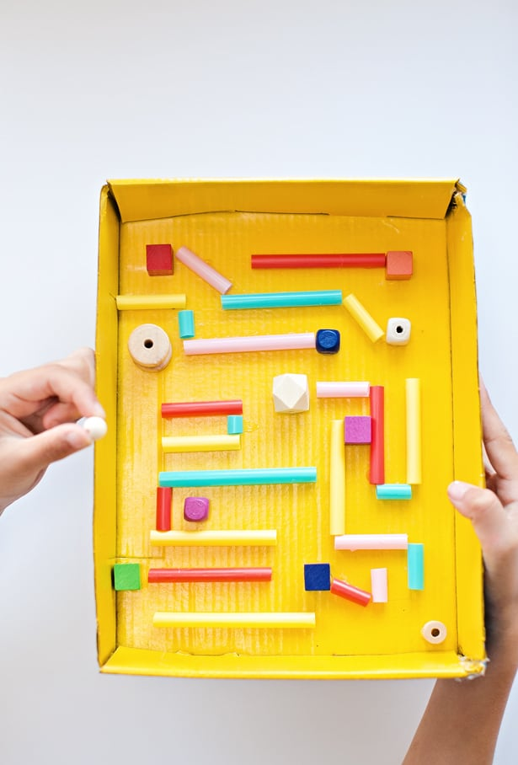
Table Coach: Guide students through the steps of the activity and control the hot glue gun.
Discussion questions:
- What is one time you had perseverance? What did you do to keep trying?
- What was difficult about building/doing the maze? How did you keep trying?
- When you disagreed with a teammate, what did you do?
- When things get difficult how do you persevere? (at home, school, with friends)
- When you don’t get a good grade? When your friends don’t play with you?
- What is something difficult for you right now?

Lead Coach: ‘Did everyone try the maze? Was there a time when your marble got stuck? What did you do when the marble got stuck? Yes, you kept trying. That’s PERSEVERANCE! When you keep trying even when it’s hard. At your tables I want you to tell your coach when you have had to persevere through something really difficult.

Materials: craft directions shallow cardboard box, large plastic straws, popsicle sticks, scissors, pencils, marbles, low temp hot glue gun, glue sticks

Homework – 40 minutes
We will have printed out some worksheets for the students to work on. They are categorized by grade level and subject.
Students will focus on working on their homework for the day.
Transitioning to homework time can be difficult...all coaches should work together to ensure students are moving to desks, pulling out their homework, or picking a worksheet from the folder. Pick a couple of students to sit with and assist them during homework time.

- Coaches: Give any help to students when asked. Help them work out any struggles they might have

- Tutor tips:
    - Don’t give the answer to the students - help them work it out together.
  - MATH: use visuals to help them see the problem more clearly; Help them spot key words in word problems and how to solve it
  - LITERATURE/ENGLISH: help them sound out difficult words; if they are struggling and do not know the word, give them synonyms and give them a push to right direct

Clean Up– 5 minutes
- Instruct students to pick up and throw away trash before they leave.
- Pick up and throw away trash.
- Clean up WC supplies
- While we wait for the parents, hang out with the kids.

- Coaches please fill out this form on how you felt Welcome Club went.
- https://forms.office.com/r/r1kpc21QTh

